

**HEALTH UPDATE**

**December 2, 2021**

Please distribute to all providers in the facility

Go to [Shasta County Health and Human Services Agency - Medical Professionals](https://www.co.shasta.ca.us/index/hhsa/professionals/medical-professionals) for an electronic version of this Health Update

**Latent Tuberculosis Infection Treatment**

**The purpose of this health update** is to provide information on the importance of diagnosis and treatment of latent tuberculosis and easy to use resource tools for managing patients.

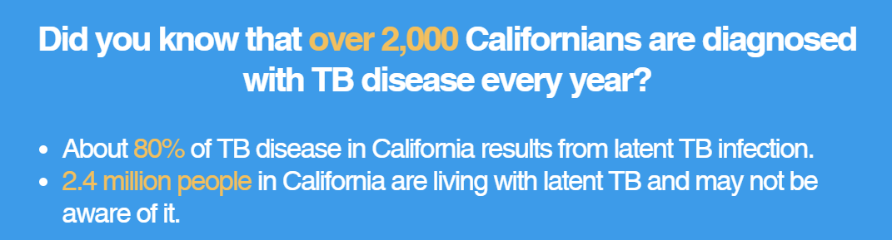

**Introduction**

Treatment of latent tuberculosis infection (LTBI) is essential to controlling and eliminating tuberculosis (TB) in the United States, because it substantially reduces the risk that TB infection will progress to active TB disease, an illness that is transmissible to others. Shasta County is seeing an increasing number of positive IGRA (Interferon-Gamma Release Assays) results, which are laboratory reportable to Public Health. A positive IGRA blood test or TB skin test indicates LTBI, a treatable condition.

**Background**

Though on the decline in 2020, California’s annual TB incidence is more than double the national incidence. Last year, TB cases were reported in 43 of California’s 61 local health jurisdictions of which 12 jurisdictions reported 1–4 cases, including Shasta county.

More than 2 million Californians have LTBI. Approximately 1.8 million were born outside the U.S., of whom only 20% are aware of their LTBI and only 12% have been treated. ***Because an estimated 80- 85% of cases occur because of progression from LTBI, treating LTBI will prevent many TB cases in California.***

**What is TB?**

Mycobacterium tuberculosis is spread from person to person through the air via droplet nuclei containing M. tuberculosis. TB usually infects the lungs, but it can also affect other parts of the body, such as the brain, the kidneys, or the spine. If another person inhales air containing these droplet nuclei, he or she may become infected. However, not everyone infected with TB bacteria becomes sick. As a result, two TB-related conditions exist: latent TB infection and TB disease.

**Latent TB Infection**

Persons with latent TB infection do not feel sick and do not have any symptoms. They are infected with M. tuberculosis, but do not have TB disease. The only sign of TB infection is a positive reaction to the tuberculin skin test or TB blood test (IGRA). Persons with latent TB infection are not infectious and cannot spread TB infection to others. Overall, without treatment, about 5 to 10% of infected persons will develop TB disease at some time in their lives. For persons whose immune systems are weak the risk of developing TB disease are much higher. A person with latent TB infection:

*Usually has a skin test or blood test IGRA indicating TB infection

*Has a normal chest x-ray and a negative sputum test

*Has TB bacteria in his/her body that are alive, but inactive

*Does not feel sick

*Cannot spread TB bacteria to others

*Needs treatment for latent TB infection to prevent TB disease

**TB Disease**

In some people, TB bacteria overcome the defenses of the immune system and begin to multiply, resulting in the progression from latent TB infection to TB disease. Some people develop TB disease soon after infection, while others develop TB disease later when their immune system becomes weak.

The general symptoms of TB disease include unexplained weight loss, night sweats, fever/chills, loss of appetite and fatigue. If the lungs are involved, symptoms often include cough (for 3 weeks or longer), hemoptysis and chest pain.

**Actions Requested**

1. **Identify patients at risk for TB infection:** Using the Risk Assessment Tool

[**California Adult Tuberculosis Risk Assessment and User Guide**](https://www.cdph.ca.gov/Programs/CID/DCDC/CDPH%20Document%20Library/TBCB-CA-TB-Risk-Assessment-and-Fact-Sheet.pdf)

(<https://www.cdph.ca.gov/Programs/CID/DCDC/CDPH%20Document%20Library/TBCB-CA-TB-Risk-Assessment-and-Fact-Sheet.pdf>)

1. **Test patients for TB infection:** TB Skin Test (TST) or Interferon-Gamma Release Assay (IGRA)

[**Fact Sheets | Testing & Diagnosis | Fact Sheet - Recommendations for Human Immunodeficiency... Clinics | TB | CDC**](https://www.cdc.gov/tb/publications/factsheets/testing/igra.htm)

(<https://www.cdc.gov/tb/publications/factsheets/testing/igra.htm>)

IGRAs are preferred for testing in:

* + Persons who have received BCG (either as a vaccine or for cancer therapy); and
  + Persons from groups that historically have poor rates of return for TST reading.

TST is preferred over IGRAs for testing children less than 5 years of age.

1. **Evaluate LTBI patients for active TB disease:** chest x-ray, symptom screen and, if indicated, sputum for AFB smears, cultures and NAAT.

[**Prevent Tuberculosis (TB) in 4 Steps: A Guide for Medical Providers**](https://www.cdph.ca.gov/Programs/CID/DCDC/CDPH%20Document%20Library/PreventTBin4%20Steps_%20AGuideforMedicalProviders.pdf)

(<https://www.cdph.ca.gov/Programs/CID/DCDC/CDPH%20Document%20Library/PreventTBin4%20Steps_%20AGuideforMedicalProviders.pdf>)

1. **Treat LTBI to prevent TB disease:** Evaluate for pregnancy and relevant medical conditions; check baseline LFTs; and treat with 3- or 4-month LTBI regimen whenever possible.

[**Prevent Tuberculosis (TB) in 4 Steps: A Guide for Medical Providers**](https://www.cdph.ca.gov/Programs/CID/DCDC/CDPH%20Document%20Library/PreventTBin4%20Steps_%20AGuideforMedicalProviders.pdf)

(<https://www.cdph.ca.gov/Programs/CID/DCDC/CDPH%20Document%20Library/PreventTBin4%20Steps_%20AGuideforMedicalProviders.pdf>)

If you have questions about this Health Update or managing LTBI patients, please contact: Cindy Wood (cwood@co.shasta.ca.us) or Don Austria (daustria@co.shasta.ca.us).