2016-2017 Goals and Objectives

The goals and objectives included in the 2016-2017 Quality Management Work Plan are based upon the DHCS Managed Care contract requirements for quality improvement work plans and Title 9 requirements in the following areas:

Service Delivery Capacity and Timeliness of Service Delivery (DHCS Site Review Protocol
FY 2014-2015: 4a, b, c)
The MHP is responsible for the monitoring of service delivery capacity and accessibility of services. The MHP will evaluate the distribution of mental health services by type of service and geography of client within its delivery system and set goals for service delivery. The MHP will set goals and monitor for timeliness of routine mental health appointments and urgent conditions, access to afterhours care, and responsiveness of the 24/7 toll-free line.

Beneficiary/Family Satisfaction (DHCS Site Review Protocol FY 2014-2015: 5a, b, c, d)
The MHP is responsible for monitoring beneficiary satisfaction and ensuring that beneficiaries are informed of their rights and the problem resolution process. The MHP may use various methods for evaluating beneficiary satisfaction including: surveys, outreach, education, focus groups, and other related activities. The MHP must evaluate at least annually, beneficiary grievances, appeals, fair hearings and requests for change of providers. The MHP is also responsible for monitoring provider appeals.

Safety and Effectiveness of Medication and Clinical Practices (DHCS Site Review
Protocol FY 2014-2015: 6; DHCS Contract 22, 23)
The MHP is responsible for monitoring and evaluating its medication practices for safety and effectiveness. (Issues: monitoring standards and protocol, medication consents)

Quality Improvement Committee Infrastructure and Activities (DHCS Site Review
Protocol FY 2014-2015: 1a, b, c, d, e; 2, 3, 7, 8)
The Committee is required to have a membership of practitioners and providers, as well as beneficiaries who have accessed specialty mental health services through the MHP and family members. Committee members should have active participation in the planning, design, and execution of the QI Program. The Committee should be involved or oversee QI activities including: recommending policy decisions, reviewing and evaluating results of QI activities, instituting needed QI actions, and ensuring follow-up of QI processes. The QI Committee must evaluate the effectiveness of the QI program and work plan and show how QI activities have contributed to improvement in clinical care and beneficiary service. The work plan must monitor previously identified issues, including tracking issues over time and provide evidence of appropriate follow-up activities.

Service Delivery Capacity – Goal 1
Goal 1 | The MHP will maintain adequate capacity for delivery of medically necessary specialty mental health services based on geographic area, that are appropriate in number and type of service.
Objective 1.a. | Monitor the number and type of service by geographic area and race/ethnicity, gender, and age and evaluate for appropriate level of service and penetration rates. Adjust service delivery when appropriate.
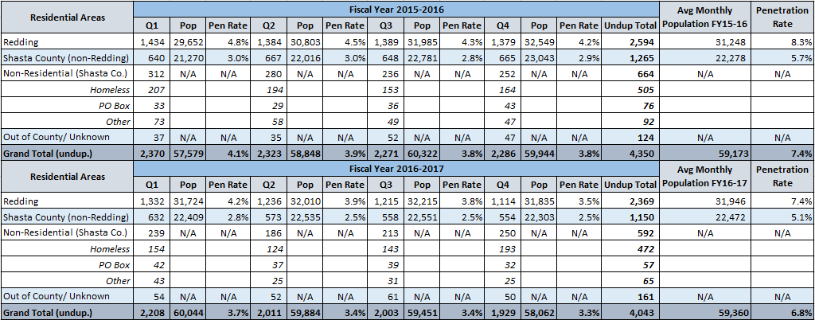
This table is an unduplicated count of clients with a Redding, Shasta County, or other address types at the time the service was rendered. Therefore, a client could be counted in the residential area of Redding and Non-Residential (Shasta Co.) during the same quarter if during that quarter, they were homeless and then were placed in housing. Therefore, the table below is an unduplicated client count by residential area and quarter. Data from FY2016-17 Q4 may be incomplete.

No specific baseline or target was set. The penetration rates for Redding and Shasta County (non-Redding) were lower in each quarter of FY2016-17 than in the corresponding quarter of FY 2015-16. The QI Committee reviews data annually and evaluates for possible areas of under or over representation. To date, the committee has not found any indication in the data of need for adjustment of services based on race/ethnicity, gender, or age.

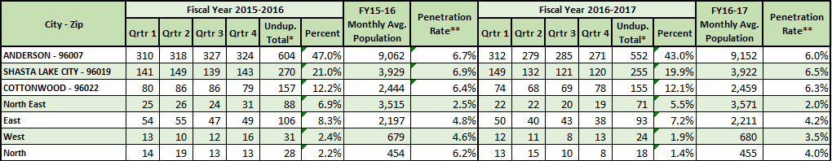
This table is an unduplicated count of clients by the residential area of the client at the time that the service was rendered. Again, if the client moved from Anderson to Shasta Lake City they would be counted in both areas for that quarter. Therefore, it is an unduplicated client count by residential area and quarter. Data from FY2016-17 Q4 may be incomplete.

North East includes: Bella Vista, 96008; Big Bend, 96011; Burney, 96013; Cassel, 96016; Fall River Mills, 96028; McArthur, 96056; Montgomery Creek, 96065; Oak Run, 96069; and Round Mountain, 96084
East includes: Hat Creek, 96040; Millville, 96062; Old Station, 96071; Palo Cedro, 96073; Shingletown, 96088; and Whitmore, 96096
West includes: French Gulch, 96033; Igo/Ono, 96047; Old Shasta, 96087; Platina, 96076; and Whiskeytown, 96095
North includes: Castella, 96017 and Lakehead, 96051 & 96070

The Shasta County (non-Redding) average penetration rate on this chart may not match the Shasta County (non-Redding) penetration rate on the previous page due to clients moving from one zip code to another during the year, which will cause them to be over counted on this chart.
No specific baseline or target was set. The relative percent of unduplicated clients by zip code for Shasta County (non-Redding) for FY 2016-17 were similar to FY 2015-16.

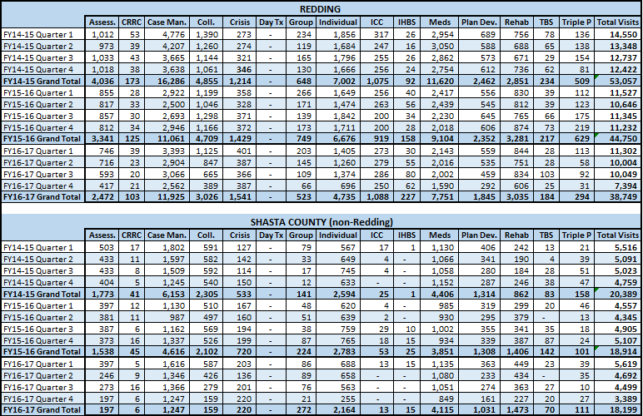
This table is a count of visits by the residential area of the client at the time that the service was rendered. If the client moved from Redding to Shasta Lake City they would be counted in both areas for that quarter. Therefore, it is a count of visits by the client’s residential area, quarter, and service type rendered. Data from FY2016-17 Q4 may be incomplete.

No specific baseline or target was set. The ratio of the number of visits for Redding and Shasta County (non-Redding) for FY 2016-17 was similar to the ratio of the number of unduplicated clients listed in table 1 of this measure.

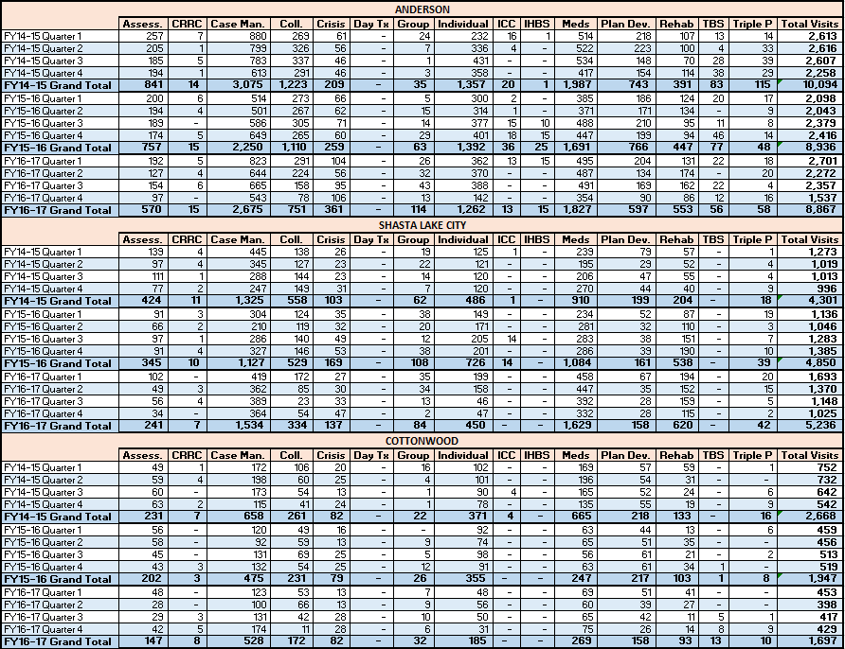
This table is a count of visits by the residential area of the client at the time that the service was rendered. If the client moved from Anderson to Shasta Lake City they would be counted in both areas for that quarter. Therefore, it is a count of visits by the client’s residential area, quarter, and service type rendered. Data from FY2016-17 Q4 may be incomplete.

No specific baseline or target was set. The ratio of the number of visits for the three cities for FY 2016-17 was similar to the ratio of the number of unduplicated clients listed in table 2 of this measure.

This table reflects the annual penetration rates for the various demographic groups for CY2015 and CY2016.
* includes one transgender and one unknown

** includes Asian, Asian Indian, Cambodian, Chinese, Filipino, Guamanian, Hawaiian, Japanese, Korean, Laotian, Pacific Islander, Samoan, and Vietnamese.
*** includes Multiple, No Response, No Valid Data, Non-White-Other, Other, and Unknown.

No specific underserved populations were identified for Shasta County. The penetration rates for state-wide underserved Female and Hispanic populations both showed an increase (closer to parity) from CY 2015 to CY 2016.

Service Delivery Capacity – Goal 2
Goal 2 | The MHP will maintain adequate capacity for timely delivery of routine and urgent specialty mental health services.
Objective 2.a. | Increase the number of Youth clients who receive first clinical assessment within 20 business days from the first request for services from 81.7% to 83.5% 10% improvement over FY 15-16 baseline).

Clients may have multiple Access Episodes during a given reporting period. Rather than using an Access Episode, the study will use the Access Treatment Plan Start Date as the beginning point and the first Assessment Service as the end point.

The following Access Episodes have been excluded:

- Access Episodes in which there were no services, or the only service was case management and the next Episode is another access Episode.
- Access Episodes that do not have an Access Treatment Plan.
- Access Episodes that occur during an open OP Episode.
- Access Episodes followed only by crisis services.

This way, Access Episodes that did not result in follow-up care were eliminated from the denominator as the client was not referred or did not continue onto therapeutic outpatient services.

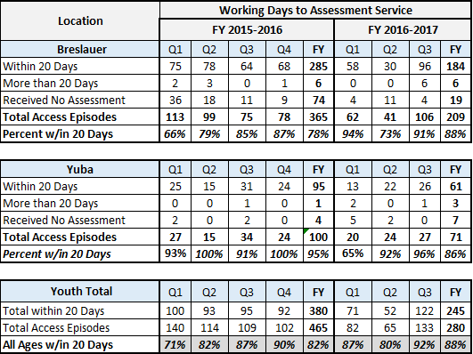

The target was met for Q1, Q3 and for the FY average in FY16-17. Data for Q4 is not yet available.

Objective 2.b. | Increase the number of Adult clients who receive first clinical assessment within 20 business days from the first request for services from 77.1% to 79.4% (10% improvement over FY 15-16 baseline).

The study will use the Open Date of the Access Episode as the beginning point and the first Assessment Service on or after the Access Episode Start Date as the end point, including all episodes for clients with multiple Access Episodes during a given reporting period.

The following Access Episodes have been excluded:

- Access Episodes that occur during an open OP Episode.
- Access Episodes with one or more crisis services charged to the access Episode.
- Access Episodes where the only service received is a case management service.
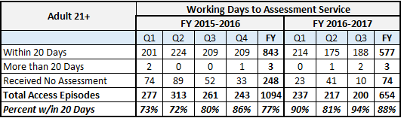

The target was met for Q1, Q2, and Q3 in FY16-17. Data for Q4 is not yet available.

Objective 2.c. | Increase the number of Adult clients who receive first psychiatric appointment within 30 days of first request for services from 53.3% to 58.0% (10% improvement over FY 15-16 baseline).

The study will use the Open Date of the Access Episode as the beginning point and the Scheduled Date of the Medical Appointment or Date of Medication Service, whichever is sooner, as the end. A Medication Service is expected when there is an Access Episode with an Outpatient Episode following. The Outpatient Episode must be opened longer than 1 day.
The following Access Episodes have been excluded:

- Access Episodes that occur during an open OP Episode.
- Access episodes in which there were no following OP episodes within 30 days.
- Access episodes that are only followed by an OP episode that opened and closed in the same day.
- Access episodes with crisis services charged to the Access episode or to OP episodes within 30 days following the access episode.
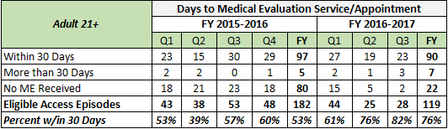

The target was met for Q1, Q2, and Q3 in FY16-17. Data for Q4 is not yet available.

Objective 2.d. | Increase percentage of Youth clients referred to Organizational Providers who are scheduled for an appointment within 10 business days of first request for services by 10%. (NVCSS from 94.6% to 95.1%; Remi Vista from 91.7% to 92.5%; VCSS from 77.2% to 79.5%)

Clients may have multiple Access Episodes during a given reporting period. Rather than using an Access Episode, the study will use the Access Treatment Plan Start Date as the beginning point and the first Assessment Service as the end point.

The following Access Episodes have been excluded:
- Access Episodes in which there were no services, or the only service was case management and the next Episode is another access Episode.
- Access Episodes that do not have an access treatment plan.
- Access Episodes that occur during an open OP Episode.
- Access Episodes followed only by crisis services.

This way, Access Episodes that did not result in follow-up care were eliminated from the denominator as the client was not referred or did not continue onto therapeutic outpatient services.
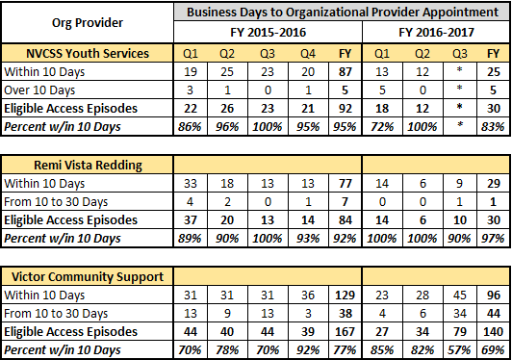

* Data is not available for NVCSS in 2017 due to issues with the EHR. Data for Q4 is not yet available.

Objective 2.e. | All beneficiaries presenting with an urgent condition, as defined in Title 9, Subsection 1810.253, will be seen within 1-day.

Measure was put into place during FY2016-17 Q4 and will begin to be measured for FY2017-18 Workplan.

Service Delivery Capacity – Goal 3
Goal 3 | Evaluate crisis prevention and discharge planning activities for clients at risk of hospitalization or that have been hospitalized in the previous 12 months.
Objective 3.a. | Maintain the percentage of Shasta County adult beneficiaries who receive a follow-up psychiatric appointment within 7 days of discharge from a psychiatric inpatient facility at FY2015/16 baseline of 79.4%. (Data will not reflect those individuals who receive psychiatric care from providers other than Shasta County Mental Health.)

The following table includes the count and percent of Adult Clients scheduled for a prescriber appointment within 7 days of discharge from a Psychiatric Inpatient Facility.

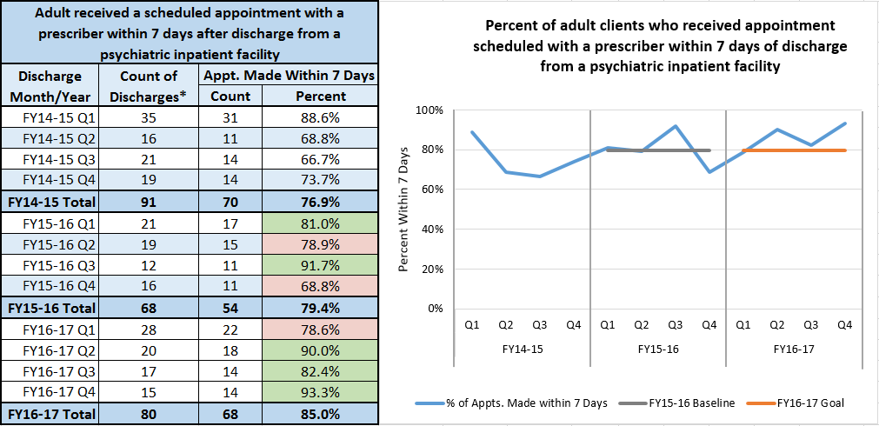

The target was met for Q2, Q3, and Q4 in FY16-17.
Objective 3.b. | 95% of Shasta County youth beneficiaries will receive follow up contact within 7 days of discharge from psychiatric inpatient facility.  (Data will not reflect those individuals who receive psychiatric care from providers other than Shasta County Mental Health and its contracted organizational providers.)

The following table includes the count and percent of Youth Clients who received a follow-up contact within 7 days of discharge from a Psychiatric Inpatient Facility.
The target was not met for FY2016-17.

Objective 3.c. | 75% of Shasta County youth beneficiaries who are prescribed psychotropic medications will be offered a follow up appointment with a prescriber within 14 days of discharge from a psychiatric inpatient facility.  (Data will not reflect those individuals who receive psychiatric care from providers other than Shasta County Mental Health and its contracted organizational providers.)

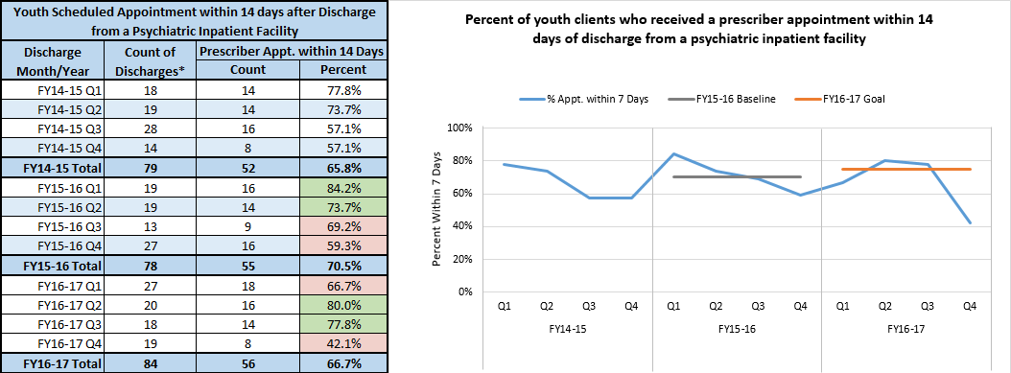

Objective 3.d. | Maintain psychiatric inpatient re-hospitalization within 30 days at 13% or less.

The following table includes the count of all psychiatric IP admissions of Adult Clients, and count and percent of those what had a readmit within 30 days of discharge.

The target was met for Q2, Q3, and Q4 in FY16-17.

Service Delivery Capacity – Goal 4
Goal 4 | Ensure access to after-hours care and the effectiveness of the 24/7 toll-free number.
Objective 4.a. | 95% of test calls will have all necessary elements logged on IRSMHS log sheet or in IRSMHS database.

Written Log of Initial Requests
 |  |  | FY1617 |  | FY1617 | FY1617 | FY1617
 |  |  | Q4 |  | Q3 | Q2 | Q1
 |  |  | % Calls where Req Met |  | % Calls where Req Met | % Calls where Req Met | % Calls where Req Met
Name of Beneficiary? |  | Business Hours | 50.00% |  | 0.00% | 75.00% | 0.00%
 |  | After Hours | 0.00% |  | 20.00% | 0.00% | 0.00%
Date of Request? |  | Business Hours | 50.00% |  | 100.00% | 87.50% | 50.00%
 |  | After Hours | 50.00% |  | 80.00% | 100.00% | 0.00%
Initial Disposition of the request? |  | Business Hours | 50.00% |  | 100.00% | 87.50% | 50.00%
 |  | After Hours | 50.00% |  | 80.00% | 100.00% | 0.00%

The target was not met in Q1, Q2. Q3 or Q4 in FY2016-17. Business Hours Calls in Q3 did meet 95% for logging of date of request and disposition of request. Q2 after hours calls did meet 95% for logging date of request and disposition of request.

Objective 4.b. | 95% of test calls requiring an interpreter will be completed successfully. Success is defined as: Correct language interpreter successfully engages with the caller.

Language Access FY1617
Q1 (July-Sept) | Business | 0.00%
 | After Hours | 33.33%
Q2 (Oct-Dec) | Business | 0.00%
 | After Hours | 100.00%
Q3 (Jan - Mar) | Business | 0.00%
 | After Hours | 100.00%
Q4 (Apr- June) | Business | 0.00%
 | After Hours | 0.00%

The target was met for Q2 and Q3 for calls during after-hours for FY2016-17.

Objective 4.c. | 100% of calls to the 24/7 Access line will be answered by a live person.

Measure was put into place during FY2016-17 and will begin to be measured for FY2017-18 Workplan.

Objective 4.d. | 100% of the time, beneficiaries will have access to after-hours care.

Measure was put into place during FY2016-17 and will begin to be measured for FY2017-18 Workplan.

Beneficiary/Family Satisfaction – Goal 5
Goal 5 | Conduct client satisfaction surveys (POQI) annually or semi-annually as required by DHCS.
Objective 5.a. | Improve client satisfaction by a 10% increase (from 2014 baseline) of Agree or Strongly Agree in the following areas:  Adult  - I like the services that I received here.  - I was able to get all the services I thought I needed.  Youth  - Overall, I am satisfied with the services I received.  - I got as much help as I needed.  Youth Caregiver  - My family got as much help as we needed for my child.

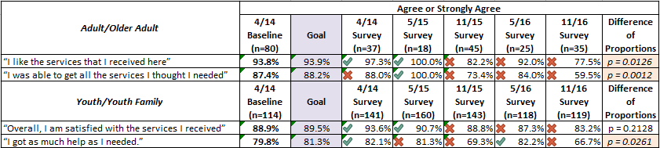

Percent of Adult/Older Adults who answered Agree or Strongly Agree to the question, “I like the services that I received here.”

Percent of Adult/Older Adults who answered Agree or Strongly Agree to the question, “I was able to get the services I thought I needed.”

Percent of Youth/Youth Families who answered Agree or Strongly Agree to the question, “Overall, I am satisfied with the services I received.”

Percent of Youth/Youth Families who answered Agree or Strongly Agree to the question, “I got as much help as I needed/My family got as much help as I needed for my child.”

Objective 5.b. | Beneficiary/family participation and response to Client Satisfaction Survey (POQI) will increase by 10% from the baseline of 2014.

Count of Adult/Older Adults who completed a survey.

Count of Youth/Youth Families who completed a survey.

Beneficiary/Family Satisfaction – Goal 6
Goal 6 | Conduct activities to assess beneficiary/family satisfaction.
Objective 6.a. | Upon implementation of the MORS, 90% of adult clients will receive a MORS assessment at least quarterly.

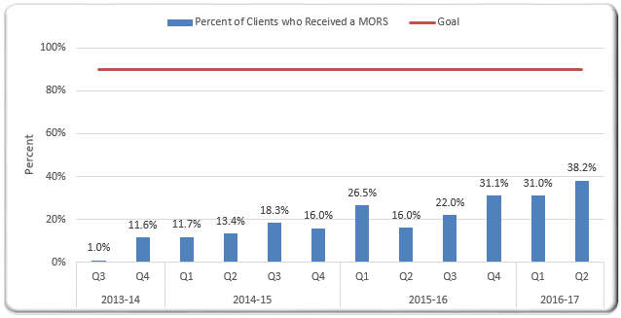

Objective 6.b. | Develop and implement a method(s) for assessing beneficiary/family satisfaction and set goals for assessment activity and satisfaction ratings. Activities may include (but not be limited to) develop an effective survey, outreach, education, and focus groups. The committee will obtain participation from consumers, family members, organizational providers, and Shasta County direct care, supervisory, and management staff.

This objective is ongoing. The QI Committee is working with the Privacy Officer to ensure a HIPAA compliant Survey Monkey application is available. Once this is completed, the MHP can begin sending surveys to clients at discharge. The QI Committee is exploring sending paper surveys in the interim.

Beneficiary/Family Satisfaction – Goal 7
Goal 7 | Evaluate beneficiary grievances, appeals, fair hearings and change of provider requests for quality of care issues.
Objective 7.a. | Grievance, Appeal, Expedited Appeal, and Change of Provider Request issues and resolutions will be reported to QI Committee semi-annually and QI Committee will evaluate for quality of care issues.

Grievance & Appeal, Summary FY1617
CATEGORY | PROCESS |  |  | DISPOSITION
 | GRIEVANCE | APPEAL | EXPEDITED APPEAL | COMPLETED | REFERRED OUT | PENDING as of June 30
ACTIONS (Appeals on Actions)
NOTICE OF ACTION - A |  | 1 |  | 1
NOTICE OF ACTION - B
NOTICE OF ACTION - C
NOTICE OF ACTION - D
NOTICE OF ACTION - E
ALL OTHER ACTIONS
TOTAL | N/A | 1 | 0 | 1 | 0 | 0
ACCESS
SERVICE NOT AVAILABLE
SERVICE NOT ACCESSIBLE
TIMELINESS OF SERVICES | 1 |  |  | 1
24/7 TOLL-FREE ACCESS LINE
LINGUISTIC SERVICES
OTHER ACCESS ISSUES | 1 |  |  | 1
TOTAL | 2 | N/A | N/A | 2 | 0 | 0
QUALITY OF CARE
STAFF BEHAVIOR CONCERNS | 6 |  |  | 6
TREATMENT ISSUES OR CONCERNS
MEDICATION CONCERN | 1 |  |  | 1
CULTURAL APPROPRIATENESS | 1 |  |  |  | 1
OTHER QUALITY OF CARE ISSUES | 3 |  |  | 2 |  | 1
TOTAL | 11 | N/A | N/A | 9 | 1 | 1
CHANGE OF PROVIDER |  | N/A | N/A
CONFIDENTIALITY CONCERN |  | N/A | N/A
OTHER
FINANCIAL
LOST PROPERTY
OPERATIONAL
PATIENTS' RIGHTS | 1 |  |  |  | 1
PEER BEHAVIORS
PHYSICAL ENVIRONMENT
OTHER GRIEVANCE NOT LISTED ABOVE
TOTAL | 1 | N/A | N/A | 0 | 1 | 0
GRAND TOTALS | 14 | 1 | 0 | 12 | 2 | 1

CHANGE OF PROVIDER; Summary FY1617
Month | Count | Pending | Resolved |  | Under 60 | Over 60 |  | 14 Day Ext Used | 1. In-teraction | 2. Con-sisent Provider |  | 3. Trmt Planning | 4. Appt Re-schedule |  | 5. Con-fidentiality | 6. Comfort Level |  | 7. Misc | Total by Type
Jul-16 | 0
Aug-16 | 0
Sep-16 | 0
Oct-16 | 0
Nov-16 | 1 |  | 1 |  | 1 |  |  |  |  | 1 |  |  |  |  |  |  |  |  | 1
Dec-16 | 0
Jan-17 | 0
Feb-17 | 1 |  | 1 |  | 1 |  |  |  | 1 |  |  |  |  |  |  |  |  |  | 1
Mar-17 | 1 |  | 1 |  | 1 |  |  |  |  | 1 |  |  |  |  |  |  |  |  | 1
Apr-17 | 0
May-17 | 0
Jun-17 | 1 |  | 1 |  | 1 |  |  |  | 1 |  |  |  |  |  |  |  |  |  | 1
Total | 4 |  | 4 |  | 4 |  |  |  | 2 | 2 |  |  |  |  |  |  |  |  | 4
The target was met for FY16-17. Grievance, Appeal, Expedited Appeal and Change of Provider Request issues and resolutions are report to the QI Committee semi-annually, and the Committee evaluates for quality of care. Reported in February and August each FY; last reported in Feb 2017.

Beneficiary/Family Satisfaction – Goal 8
Goal 8 | The QI Program will monitor provider appeals.
Objective 8.a. | 100% of appeals will be resolved within the timeframes specified by state and federal regulating agencies.

Hospital Appeals
 | FY 13/14 | FY 14/15 | FY 15/16 | FY1617
Number of Appeals | 15 | 17 | 25 | 11
Average Turnaround time | 12.5 days | 17 days | 8 days | 7.5 days
Full Appeal granted | 2 | 2 | 5 | 0
Partial Appeal granted | 2 | 5 | 7 | 4
# of Appeals granted due to additional documentation | ? | ? | 5 | 4
Total days denied | 33 | 56 | 106 | 36
Total days granted | 4 | 9 | 37 | 10

The target has been met for FY2015-16. Last reported to the QI Committee in May 2016.

Safety and Effectiveness of Medical and Clinical Practices – Goal 9
Goal 9 | Ensure that clinical practices are safe, effective, and support wellness and recovery.
Objective 9.a. | All newly hired staff, in job specifications that require it, will receive the clinical practice and documentation training within 90 days of hire. (Children’s, Adult, and Medication Support Staff)

Clinical documentation training was developed and provided to all clinical staff in June 2015. It is currently provided to new hire direct care staff by their programs. A Med Support specific training was developed and provided to all medical staff in the fourth quarter of 2016. The Committee is waiting for the Triennial audit review report to update the training.

Objective 9.b. | Review medication practices for safety and effectiveness.

Medication monitoring is currently being performed on an ongoing basis. The MHP is in the process of updating its medication monitoring practices including: 1. Conducting a competitive procurement process for potential contractors, 2. Revising the P&P, and 3. Creating a database to allow accurate and timely reporting on audit findings.

For the time-period October 2016 through May 2017, 167 charts have been reviewed by an outside reviewer. Results of the review are provided to the Clinical Division Chiefs overseeing youth and adult services, whom in turn follow-up with their staff as appropriate.

QI Program and QI Committee – Goal 10
Goal 10 | Strengthen the infrastructure and Improve the practices and effectiveness of the Quality Improvement Program.
Objective 10.a. | The QI Committee will develop a method for identifying, addressing, tracking, and evaluating quality of care issues.

The objective has been addressed and is ongoing. The QI Committee has retained the format for agendas and minutes. The format includes action items, to ensure the items are address and not “lost”. Items not addressed remain on the agenda until they are addressed. Action items are reviewed at the end of each meeting.

Objective 10.b. | The QI Committee will increase beneficiary and family member involvement in the QI Committee activities, decisions, and oversight.

The objective has been addressed and is ongoing. The Committee continues to spend significant time brainstorming methods to increase beneficiary and family member involvement. The QI Committee has broad representation, including both a family member and consumer. Both are active as schedules allow and provide significant insight to the Committee. A separate QI Data Committee meets prior to the QI Committee meeting, and that meeting includes family member representation.

Objective 10.c. | The QI Committee will assure participation of direct care staff in quality improvement (QI) activities, by having Program and Organizational Provider leads and Cultural Competency Coordinator report to the QI Committee what QI activities their staff/agencies are currently engaged in, and what programs and efforts are having a positive impact.

This objective is ongoing. The QI Committee changed the agenda for its meeting to allow reporting of QI activities at the beginning of the meeting, to be captured in the minutes. Direct care staff participate regularly in ongoing quality improvement activities, both formally and informally. Direct care staff participate on the Cultural Competency Committee and take significant responsibility for developing and presenting the annual Cultural Competency Training provided to all staff. The Cultural Competency Committee surveys all mental health staff for input regarding ideas for training. The Cultural Competency Committee presents a summary report to the Committee annually regarding its activities.

