Will the shot hurt? Will it make me sick? What about the side effects?
After COVID-19 vaccination, you might have some side effects. These are normal signs that your body is building protection.
- Tiredness
- Headache
- Muscle Pain
- Chills
- Fever
- Nausea

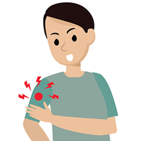
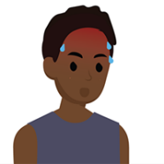
- Pain
- Redness
- Swelling

Side effects can affect your ability to do daily activities, but they should go away in a few days.
Tips to Relieve Side Effects
Talk to your doctor about taking over-the-counter medicine for any pain and discomfort you may experience after getting vaccinated.
- Apply a clean, cool, wet washcloth over the area you got the shot.
- Use or exercise your arm.
- Drink plenty of fluids and dress lightly.

Is it safe for me to get a COVID-19 vaccine if I would like to have a baby one day?
Yes. If you are trying to become pregnant now or want to get pregnant in the future, you may get a COVID-19 vaccine when one is available to you.
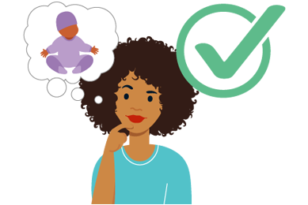
There is currently no evidence that COVID-19 vaccination causes any problems with pregnancy, including the development of the placenta. In addition, there is no evidence that fertility problems are a side effect of any vaccine, including COVID-19 vaccines.

How can I get vaccinated?
COVID-19 Vaccination Locations in Anderson

Rite Aid
www.riteaid.com
3095 McMurry Dr, Anderson, CA 96007
Safeway
www.safeway.com
2601 Balls Ferry Rd, Anderson, CA 96007
Walmart
www.walmart.com
5000 Rhonda Rd, Anderson, CA 96007
CVS
www.cvs.com
2975 East St, Anderson, CA 96007
AndersonRX
530-378-5566
2940 East St, Anderson, CA 96007
Shasta Community Health Center
myturn.ca.gov, 833-422-4255
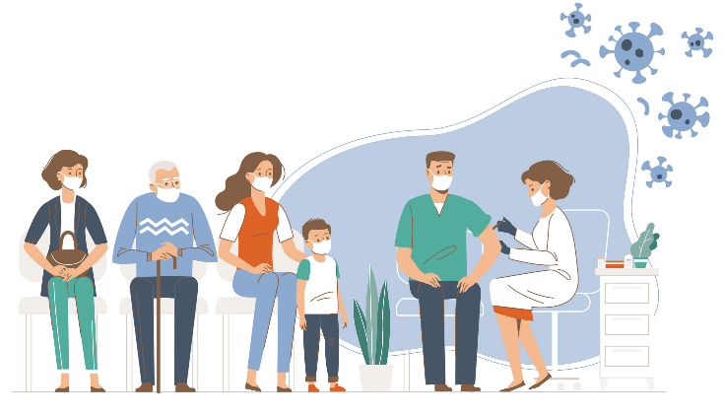
2965 East St, Anderson, CA 96007
Walk-in appointments available at most of the above locations.
Questions?
530-245-7890
1-833-422-4255
Learn more at www.ShastaReady.org
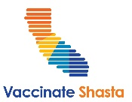
COVID-19 Vaccine Information & FAQs
Help stop the pandemic by getting a COVID-19 vaccine. It’s okay to have questions. Everyone deserves answers.

Safe. Effective. Free.
The COVID-19 vaccines are safe, effective and 100% free for everyone 12 and up in California’s 58 counties.

Why get vaccinated?
Do it for yourself, your family and your community. When you’re vaccinated against COVID-19, you protect yourself from a deadly disease. Vaccinate to stop the spread to your friends, your family, your elders, and the people who work hard to keep our communities safe and open.

¿Habla español?

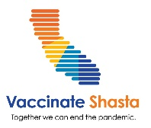
No vaccine development steps were skipped when developing the COVID-19 vaccine.
How were the vaccines developed so quickly?
Given the unprecedented public health emergency of the COVID-19 pandemic, there were groundbreaking collaborations between medical experts and researchers across the world. Researchers have been studying coronaviruses for decades, so they were able to get to work quickly on developing the COVID-19 vaccine once the genetic code of the virus that causes COVID-19 was understood. Because of the urgency of COVID-19 pandemic, both the FDA and CDC made the review and approval of COVID-19 vaccines their highest priority.

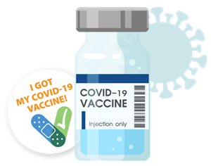
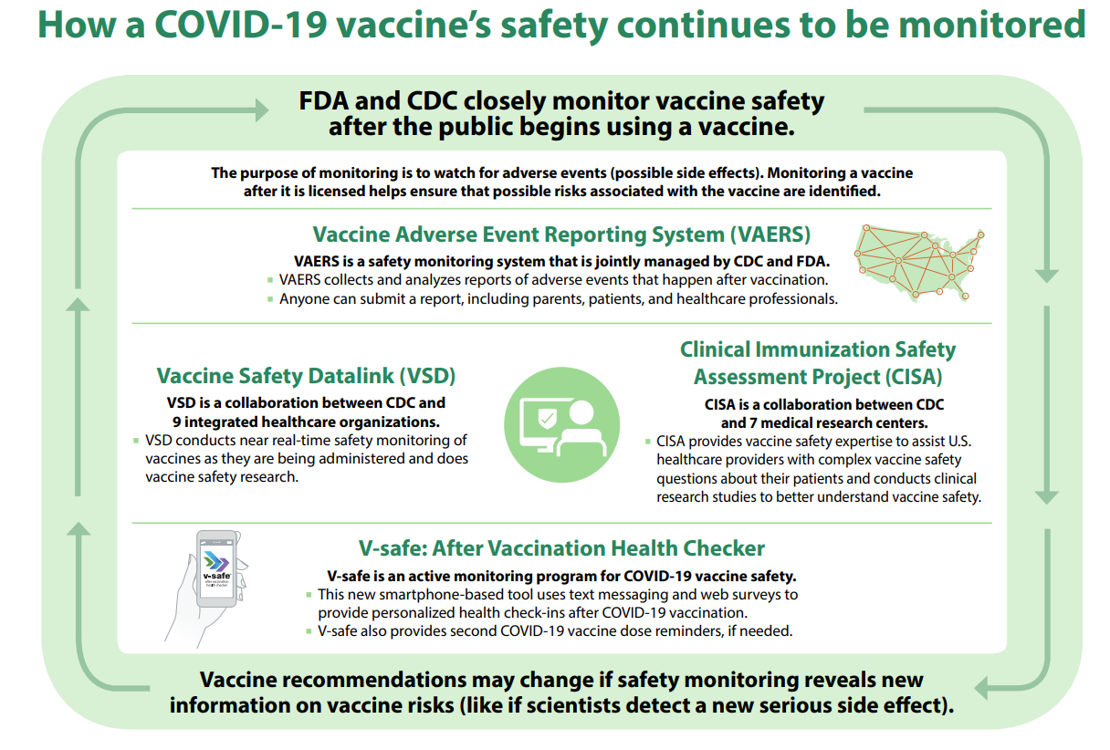
Is it better to get
natural immunity
rather than immunity
from vaccines?
Both this disease and the vaccine are new. We don’t know how long protection lasts for those who get infected or those who are vaccinated. What we do know is that COVID-19 has caused very serious illness and death for a lot of people. If you get COVID-19, you also risk giving it to loved ones who might get sick. Getting a COVID-19 vaccine is a safer choice.
How do we know if COVID-19 vaccines are safe?
They were tested in large clinical trials to make sure they meet safety standards. Many people were recruited to participate in these trials to see how the vaccines offer protection to people of different ages, races, and ethnicities, as well as those with different medical conditions. The FDA carefully reviewed all safety data from clinical trials. The Advisory Committee on Immunization Practices reviews safety data before recommending any vaccine for use. Safety continues to be monitored.
For more information, visit CDC.gov/coronavirus/2019-ncov/vaccines/

